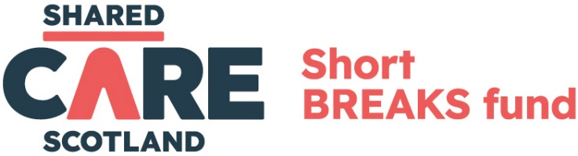

Short Break Fund: our approach to Artificial Intelligence (AI) in funding applications
Shared Care Scotland recognise that Artificial Intelligence (AI) tools such as ChatGPT, Gemini, Copilot and Claude are becoming more common in everyday work, helping people save time and improve accessibility. We recognise that many organisations and individuals applying for funding may find these tools useful.
Can AI be used in applications?
Yes, you can use AI tools to help draft the application. We will not reject an application simply because AI was used.
AI can be especially helpful if English is not your first language or if you are new to writing funding applications. Many applicants find that AI speeds up the writing process and reduces effort, allowing them to concentrate on the substance of the application, rather than the tone and style.
Using AI effectively
While AI can provide a helpful starting point, it’s important to use it wisely. AI-generated content can sometimes be too general and may not fully reflect the unique nature of your organisation; the specific details of the activities you wish to fund; and the needs of the unpaid carers or cared-for people you are seeking to support. This could weaken the application.
To strengthen the application:
- Reports reflect the authentic voices of the carers and cared for people involved. AI-generated text should not replace the unique perspectives, experiences, or language of those directly impacted by the funded project.
- All data, stories and outcomes shared are accurate, truthful and based on real experience. AI should never be used to fabricate or embellish.
- Human oversight is maintained. Any content created or assisted by AI must be reviewed and approved by someone directly involved in the project to ensure accuracy and appropriateness.
- Budgeting - funding decisions consider budget planning, detail and value for money. Ensure the budget aligns with the project activities and goals. AI-generated budget suggestions may not always be accurate - always review and adjust them to meet the funding criteria. All costs should be eligible, reasonable and good value for money.

Potential Risks of Using AI
- Accuracy: AI can sometimes provide incorrect or misleading information. Always verify AI-generated content with trusted sources and your own expertise.
- Data Privacy: many AI tools store the information entered. Be cautious about inputting sensitive or confidential data. Refer to the Information Commissioner’s Office for guidance on AI and data protection.
- Environmental Impact: AI tools use significant amounts of energy and resources. Use them mindfully and only when they add real value to the application.

Short Break Fund: our approach to Artificial Intelligence (AI) in reporting
At Shared Care Scotland, we recognise that Artificial Intelligence (AI) tools are increasingly being used to support the preparation of written reports and other forms of communication. We understand that funded organisations may choose to use AI tools - such as generative text platforms - to help draft, edit or structure their mid-grant and end-of-grant impact reports.
We support the transparent use of AI as a tool to enhance clarity, reduce workload and improve accessibility, especially where it helps small or time-pressured organisations share the difference their short breaks funding has made.
However, it is essential that:
- Reports reflect the authentic voices of the unpaid carers and cared-for people involved. AI-generated text should not replace the unique perspectives, experiences, or language of those directly impacted by the funded project.
- All data, stories and outcomes shared in impact reports are accurate, truthful and based on real experience. AI should never be used to fabricate or embellish.
- Human oversight is maintained. Any content created or assisted by AI must be reviewed and approved by someone directly involved in the project to ensure accuracy and appropriateness.
- Data privacy is considered. Many AI tools store the information entered. Be cautious about inputting sensitive or confidential data about unpaid carers or cared-for people. Refer to the Information Commissioner’s Office for guidance on AI and data protection.
We do not require organisations to declare their use of AI, but we encourage open and responsible use of these tools. If AI has played a role in helping to prepare your report and you feel it’s helpful to let us know, we welcome that transparency.
Our primary interest remains the impact of the funding; how it supported unpaid carers and the people they care for; and hearing this in your organisation’s own voice, whatever tools you use to help shape that story.

Short Break Fund: Artificial Intelligence (AI) usage statement
At Shared Care Scotland, we are committed to transparency and accountability in the administration of the Short Breaks Fund. In line with this, we wish to acknowledge that Artificial Intelligence (AI) tools, such as language models, may be used to support the drafting and preparation of funding and related documentation.
These tools are used solely to assist with improving clarity, structure and language, where appropriate. All content generated with the support of AI is carefully reviewed, edited and verified by our team to ensure accuracy, integrity and alignment with the purpose and values of the fund and Shared Care Scotland. AI tools are not used to make decisions; evaluate applications; or replace human judgment at any stage of the reporting process.
Our use of AI is part of a broader effort to improve efficiency and communication, while maintaining the highest standards of quality and trust that funders, partners and funded organisations expect from us.
If you have any questions about our use of AI or would like further information, please don’t hesitate to get in touch by emailing SBF@sharedcarescotland.com

